Nucleic acids

- Definition, purine and pyrimidine bases
- Components of nucleosides and nucleotides with examples
- Structure of DNA (Watson and Crick model), RNA and their functions

Purine and Pyrimidine

- Purines and pyrimidine are both organic compounds that take part in the synthesis of DNA and RNA, therefore they are called as the building blocks of the genetic material – DNA and RNA.
- They are nitrogenous bases that make up the two different nucleotides in DNA and RNA.
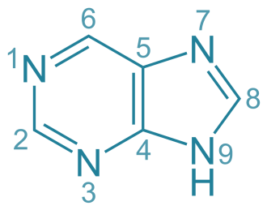
- Purine is a heterocyclic aromatic organic compound composed of a pyrimidine ring fused with imidazole ring.It comprises adenine and guanine as nucleases.
- It consists of two hydrogen-carbon rings and four nitrogen atoms.
- The melting point of purine is 214 °C .Catabolism results in the production of uric acid
Example-Purines (adenine and guanine) are two-carbon nitrogen ring base.
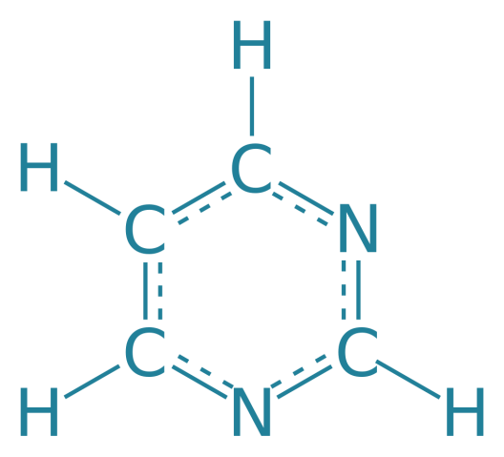

- Pyrimidine is a heterocyclic aromatic organic compound that is composed of carbon and hydrogen.
- It comprises cytosine, thymine, uracil as nucleobases.
- It consists of one hydrogen-carbon ring and two nitrogen atoms.
- The melting point of pyrimidine is 20-22 °C. Catabolism produces carbon dioxide, beta-amino acids and ammonia
Example - pyrimidines (cytosine and thymine) are one-carbon nitrogen ring bases.

Nucleoside and Nucleotide

- Nitrogenous Base: They comprise pyrimidine or purine base. DNA contains adenine (A), guanine (G), cytosine (C) and thymine (T) whereas RNA contains adenine, guanine, cytosine and uracil (U).

- Sugar: A nucleotide comprises a pentose sugar. DNA (Deoxyribonucleic acid) contains deoxyribose sugar and RNA (Ribonucleic acid) contains a ribose sugar.
  - A Nitrogenous base attached with the sugar is called “Nucleoside”.

- Phosphate: Phosphate is associated with the sugar of nucleoside by an ester bond with the 5thC hydroxyl group. Nucleotides at least contain one phosphate group.
  - A nucleoside is a purine or a pyrimidine nucleobase with a pentose sugar component, which is either ribose or deoxyribose.
Therefore:
nucleoside = nucleobase + ribose or deoxyribose
  - A nucleoside is a glycoside formed from the hydrolysis of nucleic acid.
  - In a nucleoside, the anomeric carbon is attached to the N9 of a purine (or to the N1 of a pyrimidine) by a glycosidic bond.

Nucleoside structure:
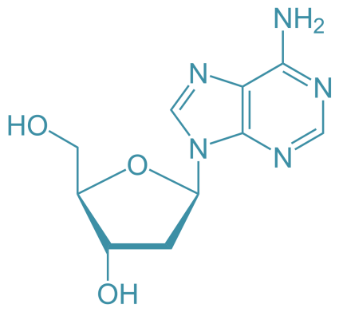
  - Nucleotides are organic molecules consisting of a nucleoside and a phosphate.
  - They serve as monomeric units of the nucleic acid polymers – deoxyribonucleic acid and
ribonucleic acid, both of which are essential biomolecules within all life-forms on Earth.
  - A molecule consisting of a nitrogen-containing base (adenine, guanine, thymine, or cytosine in DNA; adenine, guanine, uracil, or cytosine in RNA), a phosphate group, and a sugar (deoxyribose in DNA; ribose in RNA).
nucleotide = nucleoside + phosphate group
Nucleotide structure:
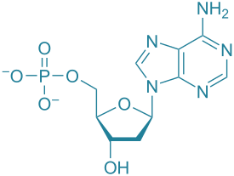

Watson and Crick model of DNA
  - DNA as an acidic substance present in the nucleus was first identified by Frederich Meischer in 1869. He named it as 'nucleon'. Due to technical limitations in isolating such a long polymer intact the elucidation of structure of DNA remained elusive for a long period of time.
  - It was only in 1953 that James Watson and Francis Crick proposed the very simple but famous double helix model for the structure of DNA.
  - The main opposition was base pairing between the two strands of polynucleotide chains.

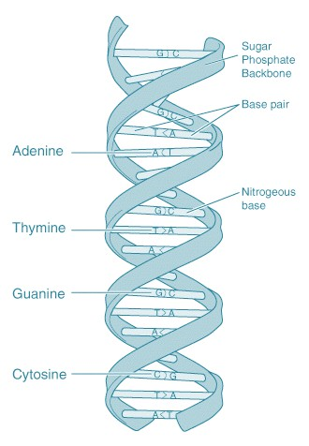
Structure of DNA double helix
The salient features of double helix structure of DNA are as follows:
  - It is made up of two polynucleotide chains.
  - The two chains have antiparallel polarity if one has polarities and the second chain must have polarity.
  - The base into strands is paired through hydrogen bond forming base pairs. Adenine forms to hydrogen bonds with thymine from opposite strands and vice versa.
  - Similarly guanine forms three H bonds with cytosine. As a result, purine comes opposite to pyrimidine.
  - Because of this approximate a uniform distance between the two strengths of The Helix occurs.
  - The two chains are called in a right-handed fashion. Pitch of the helix is and there are roughly 10bp in each turn.
  - The plane of one base pair is stacked over the other in a double helix. This confirms stability of the helical structure.
Note: The proposition of a double helix structure for DNA and its simplicity in explaining the genetic implication become revolutionary.

Function of DNA and RNA:
RNA:
  - You can think of an RNA molecule, as a disposable copy of a segment of DNA, a working copy of a single gene.
  - RNA has many functions, but most RNA molecules are involved in protein synthesis only.
  - RNA controls the assembly of amino acids into proteins.

  - Each type of RNA molecule specializes in a different aspect of this job. The three main types of RNA are messenger RNA, ribosomal RNA, and transfer RNA.

DNA has two functions:
- Hold information on how to make proteins
- Make more DNA
The main function of DNA is to store genetic information.
  - The information that DNA stores is how, when, and where to make protein.
  - The second function of DNA is simply to make more DNA; this is called replication.

